3.1.1 Largest of three numbers
Algorithm
Step 1:- Start
Step 2:- Input three numbers A, B, and C
Step 3:- If A ≥ B and A ≥ C,
→ Display A as the largest
Step 4:- Else if B ≥ A and B ≥ C,
→ Display B as the largest
Step 5:- Else,
→ Display C as the largest
Step 6:- Stop

FLOWCHART
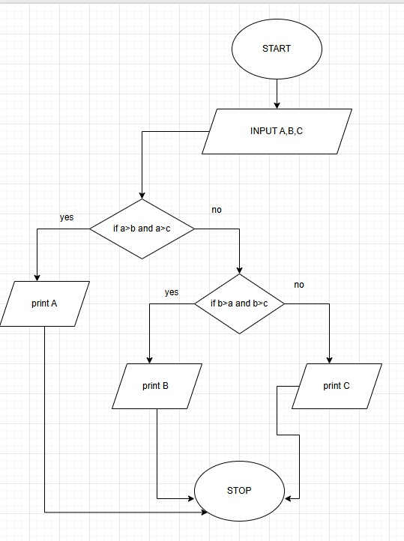

PYTHON CODE
a=int(input())
b=int(input())
c=int(input())
print(max(a,b,c))

EXECUTION